Town of West Tisbury
PLANNING BOARD P. O, Box 278 West Tisbury, MA 02575-0278 508-696-0149 planningboard@town.west-tisbury.ma.us
APPLICATION FOR SITE PLAN REVIEW
Date: June 28, 2022

Date Received by Planning Board:

Namc of Applicant and Mailing Address:

Sheila Rayyan PO Box 958, West Tisbury, MA 02575
Telephone Number(s): 508-693-5909 (home) 508-627-2302 (cell)

Name of Owner and Mailing Address (If not Applicant):
Omar Rayyan, Megan Rayyan PO Box 958, West Tisbury, MA 02575
Map and Lot # and Street Address of Subject Property:
M17 L24 95 Otis Bassett Road
Applicant is: wife of owner/ non-tenant (()wner, ^{r}renant., Purchaser, Other)
Applicable Section of Zoning Bylaw: Use Table 3. 1—1 Craft Workshop
Site Plan Date(s) and Title(s) of Plans Submitted:

Brief Description of Proposal:
This proposal is for the change of use of an existing shed, from storage to art studio use. The property is owned by my husband and his sister. The sister lives on the property, and they have agreed to allow me to use the shed to set up a pottery kiln.
I've been doing ceramics for about ten years and have been selling my work online through my website, and at art shows. I have enough demand now for my work that I would like to have my own kiln so I can have more control over the scheduling and not have to rely on others to fire my pieces. The shed will only be used for the kiln, the pottery will be created off-site.
July 6, 2022
West Tisbury Planning Board attn: Jane Rossi
We, as the owners of 95 Otis Bassett Road West Tisbury, give Sheila Rayyan permission to use the shed on our property to install and operate a ceramic kiln.
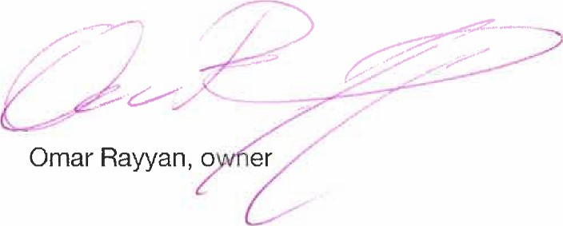
PO Box 958
West Tisbury, MA 02575
(508)693-5909
