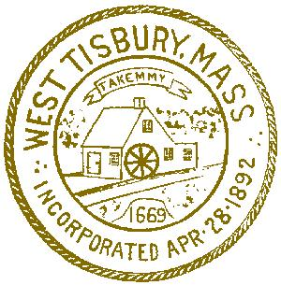
Town of West Tisbury

Animal Control Department
on

The Island of Martha's Vineyard
West Tisbury, Massachusetts 02575
508-684-8201

Anthony Cordray
Animal Control Officer
12/21/2022

During the annual barn inspections, I observed possible pollution issues caused by livestock along the Black Water Brook. I am aware of 3 farms that were contacted by the Conservation Commission, Runamuck farm owned by Brian Athearn, The farm at 5 Black Hollow Road owned by Kathryn Leonard-Peck and Blackwater Brook farm owned by Alan Cottle.
At Mr. Athearn’s farm, the pollution issue seemed to be minimal. There were 4 sheep in the paddock next to the brook and Mr. Athearn stated that “he was getting out of the sheep business”.
When the health agent and I inspected Ms. Peck’s farm the issue of pollution caused by livestock appeared to be much greater. There were 15 goats, 25 chickens, 8 turkeys, 28 water fowl, 10 rabbits and 3 peacocks. With the exception of the rabbits and peacocks, all the animals had access to the brook. The brook runs through the goat’s paddock and I observed several of them standing in the brook. The farm hand that maintains the animals stated “I use a power washer on the ground to keep the ticks down.” Due to the downward slope of the ground, the effect of using a power washer in the barn yard scrapes off the soil and washes the manure toward the brook.
I observed at Mr. Cottles farm cows within the 100’ buffer and oil like sheen on the west side of the barn toward the brook. I have seen this before and is most likely caused by manure from the cows. On the east side of the barn was a large pile of manure.
Any questions please contact my office.

Respectfully submitted
Anthony Cordray
Animal Control Officer

