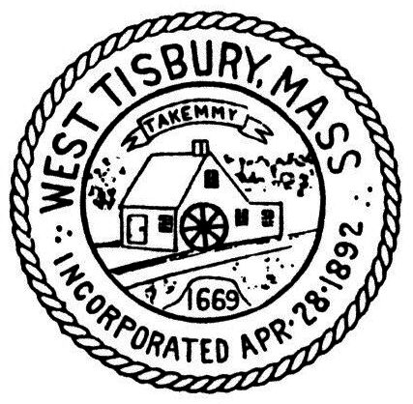West Tisbury Complete Streets Committee
Sub-committee to the PLANNING BOARD

P. O. Box 278
West Tisbury, MA 02575-0278
508-696-0149
planningboard@westtisbury-ma.gov

August 21, 2023

Mass Department of Transportation
District 5
10 Park Plaza, Suite 4160
Boston, MA 02116

Dear Mass DOT:

The Complete Streets Committee wishes to follow up on our joint site visit and listening session on the North Tisbury Bridge (crossing Mill Brook) on State Road, held on April 5th, 2022, to address both short term and longer term safety improvements. We wish to conduct a joint Zoom meeting with our committee and Mass DOT, staffed by representatives who are prepared to talk through specifics related to the following long-term improvements:

- Guard rail heights & requirements
- Materials (both bike/ped surface and dividers)
- Separations and facility dimensions
- Design exceptions
- Complete Streets requirements and waiver considerations when proposed infrastructure represents a notable improvement over existing conditions but is not necessarily fully-compatible with Complete Streets guidelines

The Committee would also like to view examples of comparable Mass DOT-owned short span bridges that have been approved by DOT in recent years in rural settings.

For shorter term improvements, we hope to discuss an expedited process to implement measures that would calm traffic speeds, considering these improvements were pledged over a year ago.

Thank you for your attention to this matter and we look forward to continuing to work with you.

Sincerely,

__________________________
Oliver Osnoss, CSC Chair

West Tisbury Select Board

_________________________
Skipper Manter

_________________________
Cynthia Mitchell

_________________________
Jessica Miller

