Dear Select Board, ZBA, and Planning Board,

I am unable to attend the Zoom meeting tonight June 1. I respectfully ask that you allow either Laura Silber or Lisa Strachan to read my letter into the record tonight. Also please find a copy of the Preservation Trusts deed that I will quote from and a letter from Chris Scott addressed to Ernest Mendenhall dated 2001.

Last Thursday night, I Andrea Rogers attended a public hearing to appeal a decision by the Building Inspector under MGL. Ch 40 A section 8 & 15 under sections 3.2.3 and 14.2 of the ZBA bylaws at 1067 State Rd. Assessors map 32 lot 66 in the VR district banning food trucks. Plus a second correspondence from the building inspector that further restricted all activities at the Grange Hall including the Vineyard Artisans Festivals.

I have attached page 2 section C of the Deeded rights of the Preservation Trust, which I will read now.

**The premises shall be used only for the following: public gatherings, organized youth activities, film showings, theatrical performances, lectures, fraternal meetings. panel discussions, concerts, weddings and wedding receptions, dinners, expositions and displays by non-profit and for profit organizations and other groups, and for other activities that have been historically conducted on a consistent basis on or from the premises.**

Chris Scotts former director of the Preservation Trusts letter from 2001 also states **:Art Shows and Craft Sales were part of the historical use of the Grange Hall since 1859. And he further states that it is the position of the Preservation Trust that the Vineyard Artisans Festivals use of the Grange Hall falls well within the uses permitted under the deed, as would other activities involving temporary sales of goods similar to the uses herein documented.**

All these stated facts were read into the last ZBA meeting and at the end of the meeting the ZBA rendered a super majority decision to appeal the decision of the Building Inspector and to grant a special permit to Andrea Rogers to operate the Vineyard Artisans Festivals including a food truck for the remainder of the calendar year at the Grange Hall and the Agricultural Society.

Here is the list of findings:

1. The Vineyard Artisans Festivals have been operating via Event Permits granted by the West Tisbury Select Board at the Grange Hall and the Agricultural Hall for 27 consecutive years.

2. Food trucks operated at the 2017, 2018, 2019, and 2021 Artisans Festivals for the entire season.

3. Deeded rights to the property reference similar uses, as described in Book 693-page 566 dated January 31, 1997

4. The definition of Retail Business in section 14.2 of the ZBA bylaws uses the word, "establishment" which the board finds to be not relative to food trucks.

5. The application was reviewed under section 9.2.2 review criteria and found to be compliant

**Lastly, remembering that all the Vineyard Artisan Festival member s live and work here on Martha's Vineyard, I urge all boards to consider how detrimental it would be to over 60 Island artists and craftsmen who's families rely on the income this home spun group has provided all these 27 years.**

**We remain in your hands.**

Thank you

Andrea Rogers/ Founder the Vineyard Artisans Festivals. since 1995

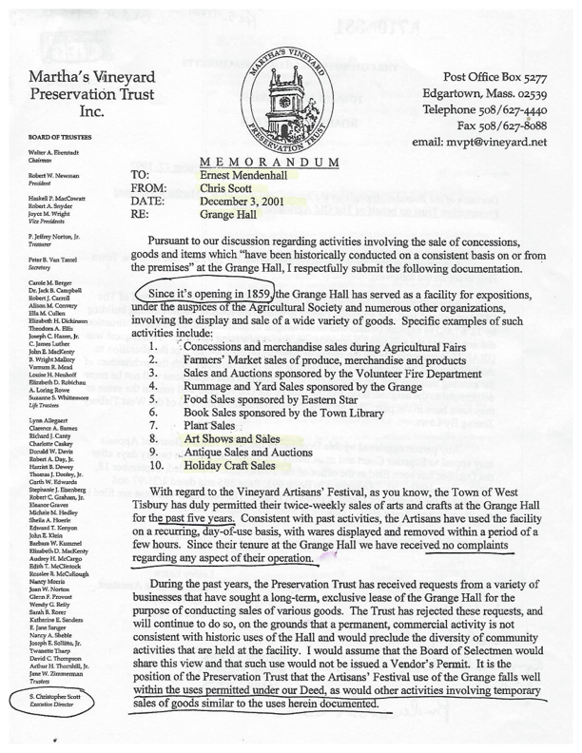

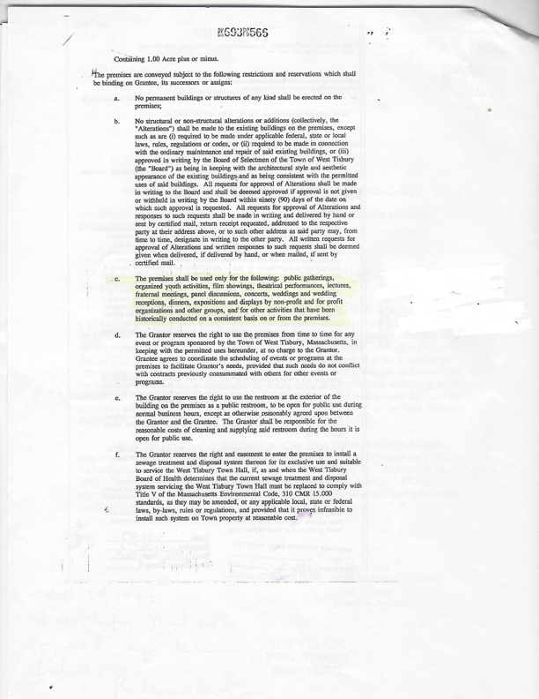

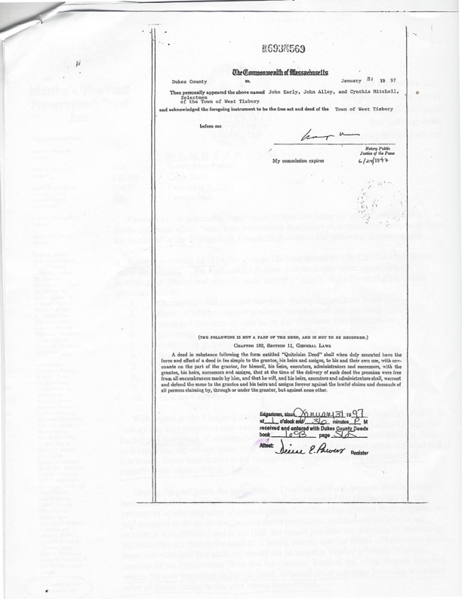

Vineyard Artisans Festivals Andrea Rogers PO Box 774 Oak Bluffs, MA 02557 [artisan02557@yahoo.com](mailto:artisan02557@yahoo.com)