**TOWN OF WEST TISBURY**

CONSERVATION COMMISSION

P.O. BOX 278

WEST TISBURY, MA 02575

PH 508-696-6404 FAX 508-696-0103

[concomm@westtisbury-ma.gov](mailto:concomm@westtisbury-ma.gov)

October 8, 2021

Mr. Brian Athearn

Mr. & Mrs. George Athearn

Runamuck Farm

P.O. Box 16

West Tisbury, MA 02575

Mr. Alan Cottle

Blackwater Brook Farm

40 Cottle Lane

Vineyard Haven, Ma 02568

Estate of Elizabeth Cottle

256 Lambert’s Cove Road

Vineyard Haven, MA 02568

Kathryn and Shelia Leonard-Peck, Trustee

5 Black Hollow Road

Vineyard Haven, MA 02568

Re: Blackwater Brook Water Quality

Dear Farming Families,

Over the summer, the Board of Health sampling of Blackwater Brook as it enters Vineyard Sound (affectionately referred to as Coca-Cola Brook in this location) tested very high for E. Coli and Enterococci bacteria. These bacteria originate in the gut of warm blooded animals and some strains can cause illness in people exposed to contaminated water.

These readings prompted the Conservation Commission to conduct two rounds of informal sampling at various locations along Blackwater Brook. The results are shown on the chart on page 2 of this letter.

The commission believes these high levels of bacteria in large part may be the result of runoff from the farms along Blackwater Brook and from livestock accessing the brook. If unaddressed, these apparently unsafe levels are likely to require formal investigation and action by the Town given the popularity of Coca-Cola creek, especially with children, and it would be far preferable if voluntary and proactive measures could address the risk

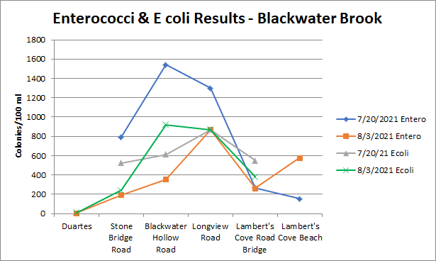

We hope you will give serious consideration to contacting the USDA Natural Resources Conservation Service (NRCS) conservation technical assistance (CTA) Program for Massachusetts. The CTA program provides technical assistance in planning and implementing conservation systems to land owners who want to address natural resources concerns. The Vineyard contact is Mia Halter. She works out of the West Wareham Field Office and can be reached at 508-295-5151 or by email at [Mia.Halter@ma.usda.gov](mailto:Mia.Halter@ma.usda.gov). A copy of the NRCS brochure is enclosed with this letter.

Ms. Halter has worked with several West Tisbury farms including Nip and Tuck, Pond View Farm and WhiteStone (formerly Red Pony). Ms. Halter’s predecessor, Don Liptak was a great resource to island farmers including Runamuck Farm, which is also adjacent to Blackwater Brook. The NRCS can provide guidance on fencing, grading, and drainage. At your request they will set up a farm visit and offer guidance on best management practices, and if a farmer agrees to work with NRCS, funding may be available.

We look forward to hearing from you and working cooperatively with each of you.

Sincerely,

Whit Griswold, Chair

Enclosure

Copies furnished as follows:

WT Board of Health

Dukes County Conservation District

Mia Halter