Project Description -- Vegetation Management

Goals
Vegetation management will increase habitat quality, biodiversity, and ecological function of the property.

The property is currently overrun by aggressive invasive species that suppress native plants and choke larger existing native trees. The extreme pressure from exotic species dramatically impacts that habitat quality for island-specific wildlife, including native bees and birds.

The proposed work will control invasive plant populations to allow native, island-specific plant communities to establish again and improve habitat quality for wildlife. Invasive plants will be managed long-term to ensure the health of native plant communities into the future.

We aim to enhance and re-establish the following island-specific native plant communities with soft land management techniques:

Martha’s Vineyard floodplain forest
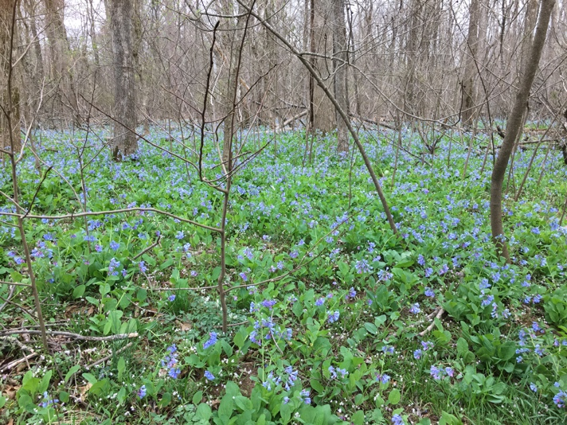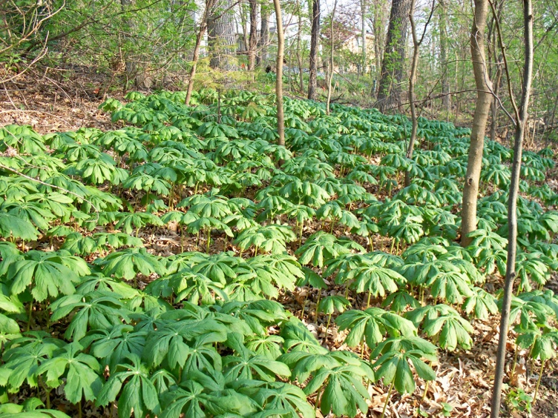

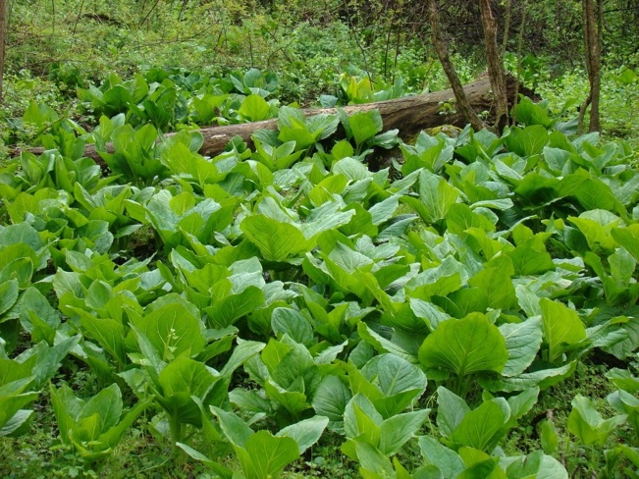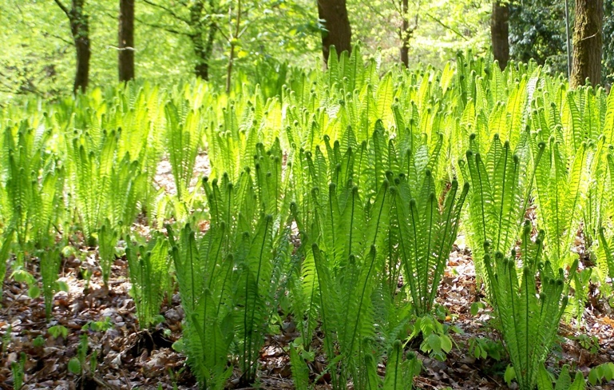

Martha’s Vineyard upland forest
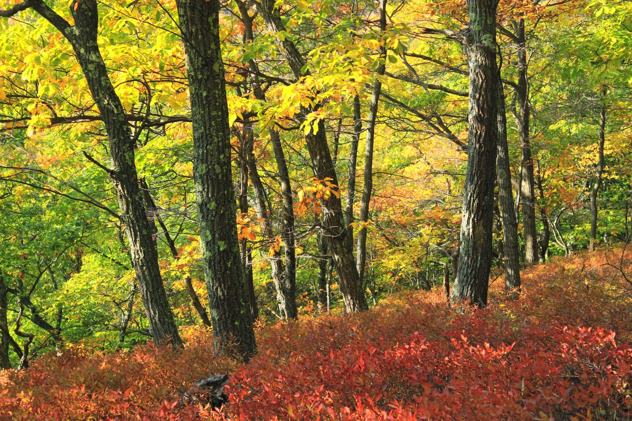

Martha’s Vineyard upland meadow
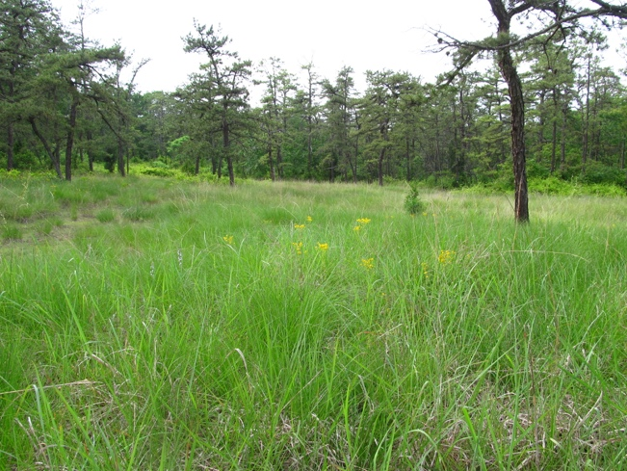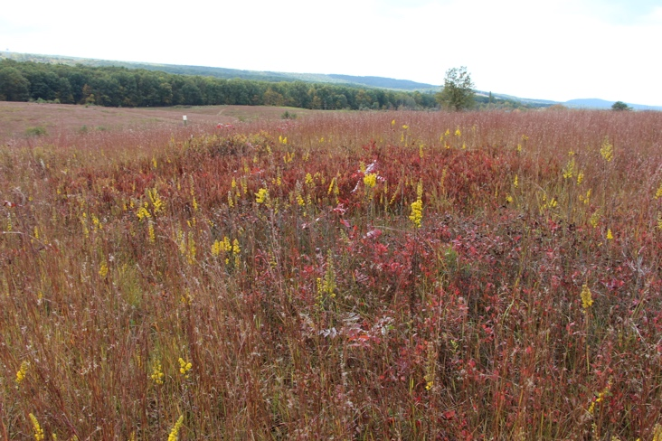

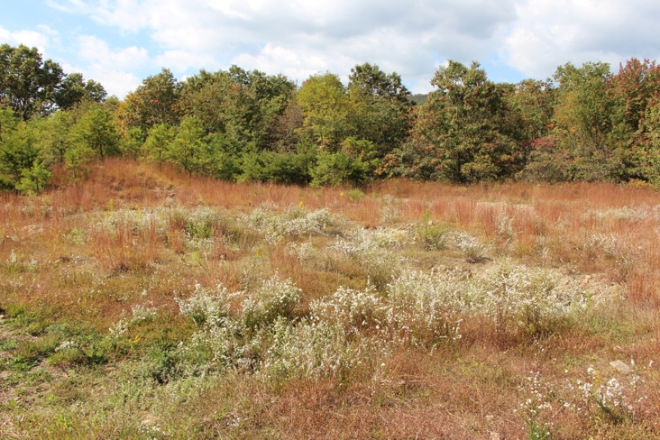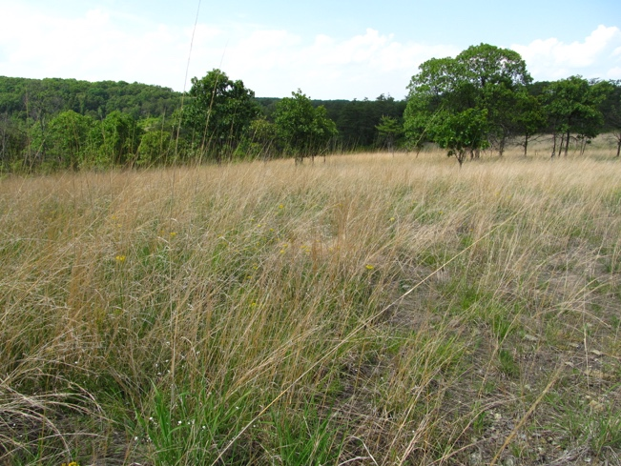

Project phases
We propose the following project phases:

Phase 1: Create access
Large parts of the property are impenetrable due to extremely thick invasive plant cover. The first step to ecologically improving these habitats is to create access.

We will remove invasive species from proposed pathways to create access to all areas of the property. We will build a small timber bridge to access the remote portions of the property. The exact pathway cannot be determined at this point because large areas of the property are inaccessible due to extremely thick invasive plant cover. The actual pathway layout will work around existing native trees to protect them.

The majority of management actions will be centered on the pathways and protect the rest of property from disturbance. For example, cut debris will be hauled out on the pathways instead of dragged through adjacent areas where this action could create undesirable disturbance.

In addition, pathways will function as a buffer between cleared areas and unmanaged invasive vegetation of neighboring properties. Even though the paths cannot stop wind-blown seed, they will make it easier to manage reinvasion of vines and suckering shrubs from adjacent properties.

Phase 2: Manage invasive species and enhance native plant communities
After access is created, careful invasive plant management will begin to gradually free the property from invasive species. The removal of invasives will immediately be followed by enhancement planting and seeding of island-native plants. This will ensure soil is quickly covered with desirable vegetation and erosion is controlled. Over time, these actions will improve habitat and native plant communities on the property.

Methods
Limiting disturbance, preventing soil erosion, and protecting existing native species are key in our approach. We will apply careful and highly selective vegetation management methods. All brush-cutting will be done by walk behind brush cutters and hand tools to avoid soil compaction, damage to root zones and existing native plants, and disturbance. We will brush and stump cut invasive plants first to manage them. Only if this does not effectively kill will we use spot treatment with selective herbicides.

We will target the following invasive species:

Ampelopsis brevipedunculata | Porcelain-berry
Berberis vulgaris | Common barberry
Celastrus orbiculatus | Oriental bittersweet
Eleagnus umbellata | Autumn olive
Lonicera japonica | Common honeysuckle
Lonicera maackii | Bush honeysuckle
Rosa multiflora | Multiflora rose
Rubus phoenicolasius | Wineberry
Toxitoxicodendron radicans | Poison ivy
Vitis ssp. | Wild grape vine

There are currently some native plants under many of the invasives. However, due to extremely thick invasive plant cover it is difficult to estimate existing native populations. Our approach would carefully peal back invasives to protect and reveal existing native plants. No large scale clear cutting will be applied. We expect to find the following species in more or less density under the current invasive cover:

Acer rubrum | Red maple
Amelanchier | Serviceberry
Ilex opaca | American holly
Morella pensylvanica | Northern bayberry
Onoclea sensibilis | Sensitive fern
Prunus spec. | Cherry
Sambuscus canadensis | Elderberry
Sassafras albidum | Sassafras
Vaccinium angustifolium | Lowbush blueberry
Vaccinium corymbosium | Highbush blueberry
Viburnum dentatum | Arrowwood viburnum

All material resulting from the cutting will be removed from the site. Some of the brush will be shredded on site and the wood chips will be used to prevent soil erosion on the pathways. No wood chips will be brought in from elsewhere to avoid contamination with additional invasive species.

