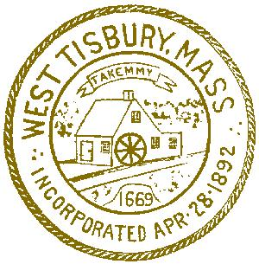
Town of West Tisbury

Police Department
on

The Island of Martha's Vineyard
West Tisbury, Massachusetts 02575
508-693-0020

Matthew L. Mincone
Chief of Police

09/29/2021

To: The Honorable Board of Selectmen

Re: Reserve Police Officer Appointment

Dear Board Members:

The department continues to recruit officers to address shortages within our roster, and the future. These officers will be used to address any emergency shortages in personnel as well as requested police details. I would like to recommend that Daniel Durawa and Roshawn Groce be appointed as Reserve Police Officers with the police department for a period of three years to be effective at your next meeting. Both individuals have the reserve intermittent police academy and are attempting to attend the Bridge Academy to become full time certified officers. I also recommend both be placed at Grade 6 Step 1 on the town’s compensation pay scale.

Thank you for your consideration.

Respectfully submitted,

Matthew L. Mincone
Chief of Police

